MOBILE COMPUTING
Bluetooth
Technology

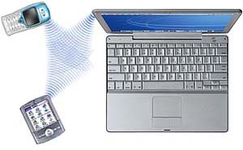

PRESENTED BY:
JIGAR A. SHAH
K. K. Wagh College of Engineering
E-Mail: jigar_a_shah83@yahoo.com

ABSTRACT
You loose one hour in the morning and you will be searching for it throughout the day. Need of the hour is communication, with least possible efforts.
Mobility, efficiency and economy are the key aspects to be considered before applying any technology and if you are looking for the same, here is the salt for your food.
Bluetooth -A technology that can enter your lives and can redefine the way you communicate, be it the speed, ease or cost. It introduces to the same and describes some of its key features so as to get a feel of ‘Bluetooth-the short distance, wireless technology that promotes ‘live and let live’ philosophy. ’ This paper emphasizes on Bluetooth wireless technology its need, working and future of this in the market.

INTRODUCTION:
Imagine the situation. You go to your office. You connect your notebook to the LAN port. You switch it on. It goes through the entire process of booting up and then provides you the option of logging in. And then you transfer data to your desktop computer. This entire process takes around 10-15 minutes, depending upon speed of your notebook. Now imagine this. You walk into your office. You just switch on the notebook. You are ready to work!
Is it a joke? No, it is reality. It is Bluetooth wireless technology. Two L.M. Ericsson Telephone employees originally designed Bluetooth technology in 1994.
Bluetooth is a developing, world wide, open, short-range radio specification focused on communication between the mobile computing devices.
Bluetooth wireless technology is a specification for a low-cost, low-powered radio and associated protocol stack that provides a short-range wireless link between notebook computers, mobile phones, PDAs, and other portable devices. The Bluetooth Special Interest Group (SIG) develops the specification, currently at version 1.1.

Problem with Existing Technology:
We already had some wireless technologies for replacing cables. Like IrDA. In this technology one is to carry information between components via beams of light in the infrared spectrum. Infrared is used in most television remote control systems, and with a standard called IrDA (Infrared Data Association) it's used to connect some computers with peripheral devices. But problem with this technology it is “Line - of – sight” technology. Thus, we have to place equipment facing each other and secondly, it gives “one - to – one” communication i.e. at a time devices can send data or receive data.
Another wireless technology is IEEE 802.11 WLAN (Wi-Fi). This is most robust, secured and long-distance wireless technology. But as it is long distance, it consumes more power and it costly. Thus it is difficult to accommodate it in mobile computing devices like PDA, Notebook computers, wireless headset, etc.

Why is it called Bluetooth?
Harald Bluetooth was king of Denmark in the late 900s. He managed to unite Denmark and part of Norway into a single kingdom then introduced Christianity into Denmark. He left a large monument, the Jelling rune stone, in memory of his parents. Choosing this name for the standard indicates how important companies from the Baltic region (nations including Denmark, Sweden, Norway and Finland) are to the communications industry, even if it says little about the way the technology works.

Architecture & Working:
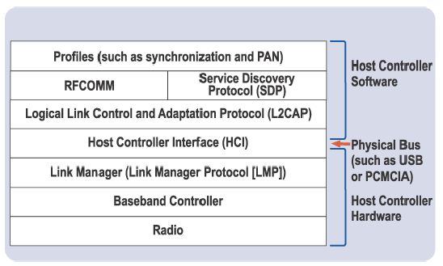

A simplified view of the Bluetooth protocol stack is presented in Figure 1. It shows the layers that correspond to the hardware and software components of a Bluetooth solution. On a PC or PDA, the interface between the two is a physical PC bus such as a USB, Compact- Flash, or PC Card bus. The hardware portion of the stack consists of the radio, base band controller, and Link Manager Protocol (LMP). The LMP is used to set up and control the link and implement the Bluetooth link-level security discussed later in this paper. The upper layers of the stack consist of the logical link control and adaptation protocol (L2CAP), client protocols, and application profiles. The L2CAP segments and reassembles data into packets for transmission. It also interfaces with client protocols such as the Bluetooth Service Discovery Protocol (SDP), which enables applications to discover which services are available on a Bluetooth device, and RFCOMM, which enables a Bluetooth device to emulate a serial port. Finally, application “profiles” define how particular user scenarios (such as dial-up networking and synchronizing data between two devices) are accomplished. Although shown as an upper application layer in the simplified diagram, a profile can be viewed as a vertical slice through the protocol stack. A profile specifies mandatory options and parameters for each protocol. This approach decreases the risk of interoperability problems between different Bluetooth devices.
Frequency Hopping and Spread Spectrum:
The baseband controller and radio are the heart of the Bluetooth hardware solution. Because of the controller's small size, low cost, and low power requirements, it can be incorporated into many electronic devices or appliances. It is ideal for PDAs with their small form factor and low power requirements. It can also be implemented on a USB device (or “dongle”), PC Card, or PC system board. Bluetooth Technology is based on the special technology known as “spread spectrum” technology, Bluetooth wireless technology operates in the 2.4-gigahertz (GHz) Industrial, Scientific and Medical (ISM) band (from 2.4 to 2.4835 GHz), dividing this frequency range into 79, 1MHz sub channels and hopping from channel to channel 1,600 times per second. This allows reducing loss of data during transmission and provides noise immune communication link. Transmitting and receiving devices must synchronize on the same hop sequence to communicate. The technology has a maximum theoretical data rate of 1 Mbps. Actual maximum throughput is approximately 400–700 Kbps, depending on the channel configuration. Bluetooth links are short range, designed to link personal electronics devices that are fairly close together - typically not more than 10 meters (or approximately 30 feet). Unlike Infrared Data Association (IrDA) devices, a Bluetooth link does not require that the devices be lined up precisely within line-of-sight of each other. For example, it is possible for a PDA and portable computer to link to each other even if they are across the room from each other or the PDA is inside a briefcase or pocket. For this reason, Bluetooth wireless technology may offer more flexibility than the IrDA ports on portable computers, mobile phones, and PDAs.
The Bluetooth baseband protocol is a combination of circuit and packet switching. Slots can be reserved for synchronous packets. Each packet is transmitted in a different hop frequency. A packet nominally covers a single slot, but can be extended to cover up to five slots. Bluetooth can support an asynchronous data channel, up to three simultaneous synchronous voice channels, or a channel, which simultaneously supports asynchronous data and synchronous voice. It is thus possible to transfer the date asynchronously whilst at the same time talking synchronously at the same time. Each voice channel (circuit switching) supports 64 kb/s synchronous (voice) link. The asynchronous channel can support an asymmetric link of maximally 721 kb/s in either direction while permitting 57.6 kb/s in the return direction, or a 432.6 kb/s symmetric link.

Network arrangement - Piconets and Scatternets:
In most current Bluetooth usage models, two devices such as the portable computer and mobile phone shown in Figure 2 are connected. However, the specification defines configurations in which up to eight devices can link together in an ad hoc WPAN called piconet. The specification also defines the methodology for piconets to connect to each other in scatternets. However, most typical usages will be limited to a few devices on a piconet. A key strength of the Bluetooth wireless technology is that a device can handle multiple, simultaneous connections. For example, a portable computer can be synchronizing with a PDA, while accepting input from a Bluetooth wireless keyboard.
Each device has a unique 48-bit address from the IEEE 802 standard. Connections can be point-to-point or multipoint. The maximum range is 10 meters but can be extended to 100 meters by increasing the power. Bluetooth devices are protected from radio interference by changing their frequencies arbitrarily up to a maximum of 1600 times a second, a technique known as frequency hopping. They also use three different but complimentary error correction schemes. Built-in encryption and verification is provided.

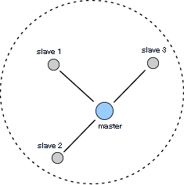 Piconet and Scatternet:

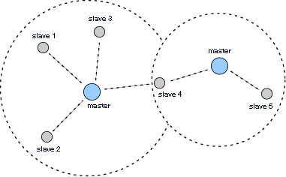

Connection protocol in network:
Standby: Devices not connected in a piconet are in standby mode. In this mode, they listen for messages every 1.28 seconds over 32 hop frequencies (fewer in Japan, Spain, and France).
Page/Inquiry: If a device wishes to make a connection with another device, it sends out a page message, if the address is known, or an inquiry followed by a page message, the inquiry method requires an extra response from the slave unit, since the MAC address is unknown to the master unit.
Active: Data transmission occurs.
Hold: When either the master or slave wishes, a hold mode can be established, during which no data is transmitted.
Sniff: The sniff mode, applicable only to slave units, though not at as reduced a level as hold. During this mode, the slave does not take an active role in the piconet, but listens at a reduced level.
Park: Park mode is a more reduced level of activity than the hold mode. During it, the slave is synchronized to the piconet, thus not requiring full reactivation, but is not part of the traffic. In this state, they do not have MAC addresses, but only listen enough to keep their synchronization with the master and check for broadcast messages

Most Commonly Implemented Application Profiles:
Generic Access Profile (platform for all other profiles)
Service Discovery profile
Serial Port Profile
Dial-up Networking Profile
Generic Object Exchange Profile
Audio Gateway/ Headset Profile
PAN Profile
File Transfer Profile

Security:
As radio signals can be easily intercepted, Bluetooth devices have built-in security to prevent eavesdropping or falsifying the origin of messages (spoofing). The main security features are:
- A challenge-response routine - for authentication, which prevents spoofing and unwanted access to critical data and functions.
- Stream cipher - for encryption, which prevents eavesdropping and maintains link privacy.
Session key generation - session keys can be changed at any time during a connection.

Three entities are used in the security algorithms:
- The Bluetooth device address (IEEE 802.11) (48 bits): is a public entity unique for each device. The address can be obtained through the inquiry procedure.
- A private user key (128 bits): is a secret entity. The private key is derived during initialization and is never disclosed. This key can be encrypted.
- A random number (128 bits): is different for each new transaction. The random number is derived from a pseudo-random process in the Bluetooth unit.
In addition to these link-level functions, frequency hopping and the limited transmission range also help to prevent eavesdropping.

Error Correction Algorithm:

Three error correction techniques are defined:
- 1/3 rate forward error correction code (FEC)
- 2/3 rate forward error correction code (FEC)]
- Automatic repeat request (ARQ)
The FEC methods are designed to reduce the number of retransmissions. However, the overhead significantly slows transmissions, so is generally not used in relatively error-free environments, with the exception of packet headers. The ARQ scheme requires that the header error and cyclic redundancy checks are okay. When they are, an acknowledgement is sent. When they aren't, the data is resent.

APPLICATIONS:
.
- This technology is mainly used in mobile computing devices like PDA, Cell phones, Laptops, Modems, etc.
- It is also used in ad hoc type wireless networking.
- It is used as communication media for process control systems.
- This technology is also used in connecting Medical and Scientific research equipment.
- Robotics is another field where it can be very useful. Different robots can be programmed to synchronize their movement and perform combined operation.

CONCLUSION:

Bluetooth is not just a new trend in wireless technology, but also a key to wireless future. It is the technology for providing distortion-free communication and data transfer. It will enable human to move faster and will make life easier. This technology is not designed for replacing existing wireless technology but to co – exist with them. This is future ready technology for short distance communication and ad hoc type networking.
References:
- Bluetooth – connect without cables, by Jennifer bray and Charles F. Struman, Pearson Education Asia.

Websites:
www.bluetooth.com
www.bluetooth.org
www.ieee.org
www.itpapers.com
www.ericsson.com/bluetooth.htm

Paper Title: Mobile computing and Bluetooth technology
Author(s) Name: JIGAR A.SHAH
Institution: K. K. WAGH COLLEGE OF ENGG. , PANCHAVATI, NASIK
Address: K. K. WAGH BOYS HOSTEL, PANCHAVATI, and NASIK
Pin code: 422003
Email id: shahja64@hotmail.com, jigar_a_shah33@yahoo.com

