WIRELESS TECHNOLOGY
Coexistence of
Wi-Fi
And
Bluetooth

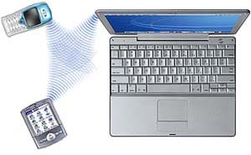

PRESENTED BY:
JIGAR A. SHAH,
K. K. Wagh College of Engineering,
Nasik.
E-Mail: jigar_a_shah83@yahoo.com
Phone: 9890543141

Coexistence of Wi-Fi and Bluetooth

Abstract:
The wireless revolution is underway, and devices based on radio technologies are expected to become a significant market in the next several years. Mobile phones, cordless phones, walkie-talkies, car door openers, and garage door openers are just a few examples of radio devices that have already achieved widespread adoption in the marketplace.
Out of the past several years, two innovations in wireless radio technology have captured our attention: Bluetooth (WPAN) and Wi-Fi (IEEE 802.11b-WLAN). These wireless communication technologies show great promise in transforming how people work and communicate with each other. These technologies are complementary rather than competing.
Both Wi-Fi and Bluetooth products utilize the unlicensed 2.4 GHz ISM band. Due to their dependence on the same band, the potential for interference exists. Both Wi-Fi and Bluetooth fail gracefully in the presence of interference. By this is meant that the communication protocols are very robust and include mechanisms for error checking and correcting, as well as requesting that corrupted packets be resent. Therefore the result of increasing levels of interference is almost always confined to a slowing of the data rate as more packets need to be resent.
This paper analyzes different approaches to resolving the interference problems between the Wi-Fi and Bluetooth wireless technologies. This analysis explores the strengths and weaknesses of these interference mitigation approaches, and goes on to explain what is necessary for achieving satisfactory combination performance and true “Coexistence without Compromise”. In investigating different approaches to interference mitigation, this paper gives technical data and uses common wireless technology terms.
Terms and Keywords: coexistence, Wi-Fi, Bluetooth, AFH, Wireless LAN (WLAN), Personal Area Network (WPAN), interference.

- INTRODUCTION
The 2.4 GHz Industrial, Scientific, and Medical (ISM) band is poised for strong growth. Fueling this growth are two emerging wireless technologies: WPAN (Wireless Personal Area Network) and WLAN (Wireless Local Area Network). The WPAN category is led by a short-range wireless technology called Bluetooth Designed principally for cable replacement applications, most Bluetooth implementations support a range of roughly 10 meters, and throughput up to 721 Kbps for data or synchronous voice transmission. Bluetooth is ideal for applications such as wireless headsets, wireless synchronization of PDAs with PCs, and wireless PC peripherals such as printers, keyboards, or mice.
In the WLAN category, several technologies are competing for dominance; however, based on current market momentum, it appears that Wi-Fi (IEEE 802.11b) will prevail. Wi-Fi offers throughput up to 11 Mbps and covers a range of approximately 100 meters. With WLANs, applications such as shared Internet access, e-mail, and file sharing can be done in the home or office, resulting in new levels of freedom and flexibility.

- OVERVIEW OF WI-FI AND 802.11b STANDARDS
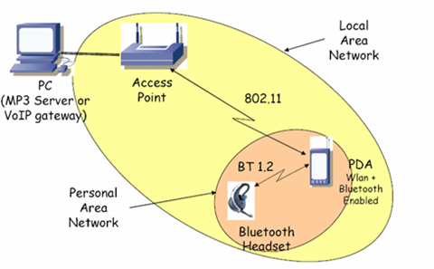
The IEEE 802.11b standard is a specification for Wireless Local Area Networks (WLAN). The Wireless Ethernet Compatibility Alliance (WECA) acts as a certification organization for products that interoperate with one another via the IEEE 802.11b standard. Products that achieve certification are deemed Wi-Fi compliant. Wi-Fi systems transmit data in the unlicensed 2.4GHz ISM band. Data is transmitted on BPSK and QPSK constellation at 11Mbps. Wi-Fi uses Direct Sequence Spread Spectrum (DSSS) technology. Each Wi-Fi network maintains the same frequency usage over time and only uses a subset of the 83.5MHz available. The IEEE 802.11b standard defines 11 possible channels that may be used. Each channel is defined by its center frequency. The center frequencies are at intervals of 5MHz from one another. The associated channels are numbered from one to 11.
- OVERVIEW OF BLUETOOTH
The Bluetooth standard is a specification for Wireless Personal Area Networks (WPAN). Although products based on the Bluetooth standard are often capable of operating at greater distances, the targeted operational area is the area around an individual, e.g. within 10 meters of the user. The Bluetooth standard is based on frequency hopping spread spectrum technology (FHSS). Although at any point in time, the Bluetooth signal occupies only 1MHz, the signal changes center frequency (or hops) deterministically at a rate of 1600Hz. Bluetooth hops over 79 center frequencies, so over time the Bluetooth signal actually occupies 79MHz. Bluetooth data is transmitted on FSK.3. The 2.4GHz ISM Band congestion
Figure 1

“Coexistence,” the ability for multiple protocols to operate in the same frequency band without significant degradation to either’s operation, has recently become a significant topic of analysis and discussion throughout the industry. This is due to several factors. Both protocols are expecting rapid growth, and because they both operate in the 2.4 GHz frequency band, the potential for interference between them is high. Consequently, more and more usage models are being discovered in which it is desirable and necessary for both Bluetooth and Wi-Fi to operate simultaneously and in close proximity. One of the possible scenario is as shown in fig.

- WI – FI AND BLUETOOTH COEXISTENCE TESTING
Since Bluetooth devices hop over 79 MHz of the ISM band and IEEE 802.11b devices require approximately 16MHz of bandwidth to operate, it is not possible to have both Wi-Fi and Bluetooth products in the same area without the chance of interference. Due to the potential for interference, a series of coexistence tests have been run with actual Bluetooth and Wi-Fi products to determine their level of coexistence. A summary of the testing is provided in the following sections.

  - Testing Setup
The throughput testing was performed with a Wi-Fi certified access point (AP) and station. The Wi-Fi station consisted of a laptop computer with a Wi-Fi PCMCIA card. The Bluetooth devices that were used in the testing were also PCMCIA cards. Two laptops were used to enable one Bluetooth master and one Bluetooth slave.
This test was intended to obtain empirical data-throughput results, corresponding with certain realistic scenarios in which Bluetooth and Wi-Fi connections may coexist. It is important to realize that many different coexistence scenarios are probable in realistic usage, each characterized by different relative distances, applications, and performance measures (e.g. voice/image quality or data latency, instead of throughput). In this paper most common possibilities of testing are mentioned.

  - Baseline Performance
To obtain the maximum throughput for both the Bluetooth and Wi-Fi networks when there is no interference, baseline tests were performed

    - Wi-Fi Throughput
To obtain a baseline for Wi-Fi, data was transferred from the access point to the station. Thus during the test, the majority of the packets going from the access point to the station were large payload data packets, while the majority of packets going from the station to the access point were short acknowledgment packets.
The distance between the Wi-Fi access point and the Wi-Fi station was varied while the two devices had a line of sight between one another. The result is that the devices maintain a connection speed in excess of 5.5Mbps up to the maximum distance at which the test was performed of 250 feet.

    - Bluetooth Throughput
In analogous fashion to the Wi-Fi baseline throughput testing, data was transferred from the Bluetooth master to the Bluetooth slave with no interference in the area. The resulting throughput was approximately 550 kbps at all distances up to 250 feet. Again all testing was performed with a line of sight between the devices under test.

  - Wi-Fi Performance with Bluetooth Interferer
In this section the results of two key tests will be shown. The first test is the same as the baseline throughput test in Section 4.2.1 except that a Bluetooth master and slave are both placed within10cm of the Wi-Fi station. This test is a worst case for Wi-Fi networks. The Bluetooth devices used a transmit power of 100mW, and the Wi-Fi devices used a transmit power of 30mW. Both Bluetooth devices were located within
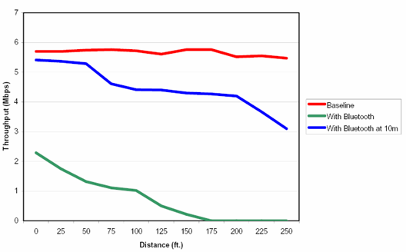
10cm of the Wi-Fi device that was attempting to receive data. It is observed that the second test is similar to the first test, except the Bluetooth interferers are moved 30 feet away from the Wi-Fi station.
Figure 2
The results of these two tests are shown along with the baseline Wi-Fi throughput in Figure 9.
When the Bluetooth interferers are very close to the Wi-Fi station, the impact on performance due to interference is substantial. However, when the Bluetooth interference is moved as little as 10 meters away, the throughput is only minimally reduced compared to the baseline.
  - Bluetooth Performance with IEEE 802.11b WLAN Interferer
To determine the effect of Wi-Fi as an interferer on a Bluetooth network, the same experiments that were carried out in Section 4.3 were carried out again with the Bluetooth and Wi-Fi devices exchanging locations. The results of the tests are shown in Figure 10. It can be seen from the results that Bluetooth throughput is impacted when a Wi-Fi device is very close. On the other hand, when the Wi-Fi device is moved away, the Bluetooth throughput significantly improves and is approximately ninety percent of the baseline throughput independent of range. These experiments show that when Bluetooth and Wi-Fi devices are at a reasonable distance from one another, both types of devices obtain the large majority of the throughput that would have been obtained if there were no interference. However, these experiments also demonstrate that interference between the two does degrade performance of both Bluetooth and Wi-Fi devices. In the following sections, the causes of the interference are analyzed and several solutions are discussed.

- INTERFERENCE MITIGATION APPROACHES
Due to the potential for other devices operating in the same band, it is necessary to imply features that allow for continued robust performance even in the presence of other devices. Fortunately, the regulations in the 2.4GHz band and most unlicensed bands prevent any device from using more than its fair share of the band. The following sections detail ways to improve coexistence and robustness of Bluetooth and Wi-Fi devices.
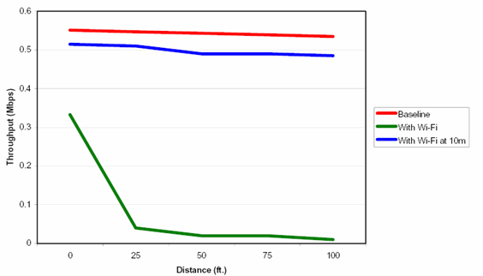
Figure 3
  - Dynamic Channel Selection for Wi-Fi Networks
One of the best ways to coexist is to avoid using the frequencies in the 2.4GHz ISM band that are occupied by others.
In case of Wi-Fi, the three collocated networks use channels one, six and eleven to avoid interfering with one another. In current Wi-Fi products, the user or system administrator selects the channel. It is possible to dynamically select the channel on which a Wi-Fi network will operate. Dynamic channel selection allows the Wi-Fi access point itself to determine which channel is best to use depending on the current usage of the band. Determination of which channel is the best to operate on can be achieve by several methods:
- Packet Error Rate
- Channel Noise
- Channel Multipath and Intersymbol Interference
- Received Signal Strength
Using the best channel available is not only good for the Wi-Fi network, but it is also good for other users of the 2.4GHz ISM band.

  - Adaptive Fragmentation for Wi-Fi Networks
Wi-Fi networks have the ability to fragment packets to limit their length. When there is no interference on the network, fragmenting lowers the network throughput, because of the increased overhead of packet headers. However, in the presence of interference, it has been shown that fragmentation can actually increase the throughput. By decreasing the length of each packet, the probability of interference during a Wi-Fi packet can be reduced. There is a tradeoff that must be made between the lower packet error rate that can be achieved by using shorter packets and the increased overhead of more headers on the network.

  - MAC layer switching
In this approach allowing only one to transmit at a time does MAC level switching. But in case of high Wi-Fi QoS activity performance of AP degrades.

  - Transmit Power Controls
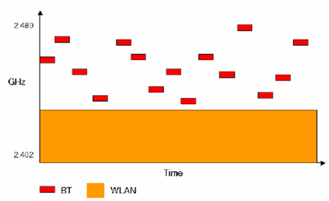
When using a shared resource such as the 2.4GHz ISM band, it is important to not use more of the resource than is actually required. This can be thought of as a golden rule for using unlicensed bands Power control is a mechanism that is relatively easy to understand and implement, yet can yield great performance improvements for all users of the band.

  - Adaptive Frequency Hopping
Frequency hopping devices have an inherent level of robustness due to the fact that they do not continually transmit at the same frequency.
Figure 4
The changing of the transmit center frequency or hopping means that the probability of colliding with the transmission of another device at any particular time is very small. The level of robustness to interference that Bluetooth devices currently have is obtained blindly, since the transmitter uses no knowledge of the interference in the channel.
Adaptive Frequency Hopping (AFH) is available as a feature in the Bluetooth 1.2 Specification. The purpose of AFH is to allow Bluetooth devices to improve their immunity to interference while allowing them to avoid causing interference to other devices or systems in the ISM band. The basic principle is that Bluetooth channels are classified into two categories, used and unused (or good and bad); where used channels are part of the hopping sequence and unused channels are replaced by used channels in a pseudo-random way in the hopping sequence. This classification mechanism allows Bluetooth devices to use 79 or fewer channels required in the BT1.1 specification. Note that in the US at least 75 channels (MHz) were required until 2002 when the FCC changed the regulations. The current minimum number of channels in the US is 15. Since the Bluetooth specification is a worldwide specification and because there are other places (such as Europe) that require at least 20 channels, the minimum number of channels allowed by the Bluetooth 1.2 specification, Nmin, is 20. Output after implementing AFH is as shown in fig.

  - Basic Building Blocks to the Coexistence Solution
Implementing each coexistence solution involves the use of a variety of building blocks that can include the data collection engine, data analysis algorithms, hardware interfaces, software interfaces, channel avoidance, priority transmission scheme and AFH.
Figure shows the coexistence blocks and interfaces. The major blocks in the system are the Bluetooth device, 802.11b and/or 802.11g and a host. In most cases where the two devices are collocated, the host is a PC or a palm-top device. The host contains the upper Bluetooth stack and drivers as well as the 802.11 drivers.
In the Bluetooth device the following blocks and interfaces may exist for any particular co-existence solution:

- Data Collection Engine
- Data Analysis Algorithms
- Hardware Interface(s)
- Software Interface
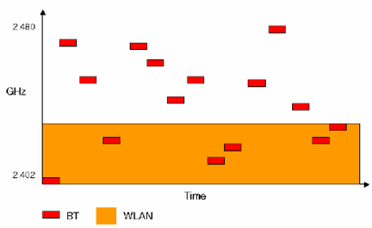
- Channel Avoidance
Figure 5
- Adaptive Frequency Hopping
- Priority Transmission Scheme

    - Channel Classification
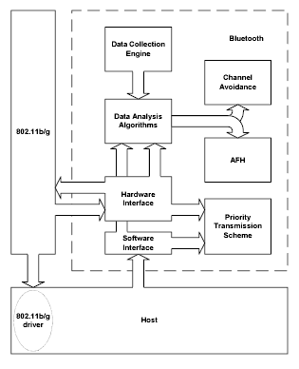
There are two major parts to channel classification. As shown in Figure 4, the first part is the data collection engine and the second part is the data analysis algorithms. The output of the channel classification is the set of used and unused channels (the Channel Map) used by AFH and/or a channel avoidance mechanism.
Figure 6

    - Data Collection Engine
The Data Collection Engine periodically gathers metrics on every channel. The number of metrics collected on each channel is configurable as are threshold levels and the metric gathering period.
    - Data Analysis and Channel Classification
At the end of the metric collection period, the data is analyzed to determine which channels are good and which are bad. Although the primary metrics used by the analysis software are from the local data collection engine, channel classification may include metrics from the host (via HCI_set_AFH_Channel_Classification), from a hardware interface, or from slaves if they are BT1.2 devices and are enabled to report channel classification information (via LMP_channel_classification reports). These metrics, along with configuration parameters, are processed through a series of proprietary filters and algorithms. The result is a Channel_Map that is used as an input to the AFH and UltimateBlue Coexistence Technology mechanisms.

- STANDARDIZATION ACTIVITIES
- IEEE 802.15 WPAN has formed following task groups:
  - TG1 (802.15.1) - objective of reformulating the lower levels of the Bluetooth 1.x spec into an IEEE standard for MAC and PHY.
  - TG2 (802.15.2) - objective of creating Recommended Practices for the Coexistence of wireless devices operating in the 2.4 GHz ISM band.
- Bluetooth SIG Coexistence Working Group has established a working group similar to TG2 (802.15.2) to address the same concerns of coexistence in the 2.4 GHz band. It has published Bluetooth 1.2 specifications with solution to coexistence problem.

  - Modification in Bluetooth SIG specification
To facilitate the introduction of AFH it was necessary for the Bluetooth SIG to update the Bluetooth Specification concerning the baseband, Link Manager Protocol (LMP) and Host Controller Interface (HCI). These changes, among others, are included in version 1.2 of the Bluetooth Specification, currently being adopted.

    - Baseband
The updated baseband describes the algorithm used for generating an adapted hop channel set. This operation is performed through an added function for re-mapping the hop channel set.

    - LMP (Link Management Protocol)
The Link Manager Protocol has been updated with the addition of new messages for communicating the bit mask that identifies which channels may be used and which are to be avoided. The bit mask consists of 79 bits, with the first bit representing channel 0 and the last bit representing channel 78. A bit value of 1 indicates that the channel is to be used, while a value of 0 specifies that the channel be excluded from the hop set.

    - HCI (Host Controller Interface)
Modification of the Host Controller Interface consists basically of two new commands. The first is used to exclude certain channels from the list of possible. The HCI may not dictate which channels are to be used, but does have the ability to discard certain channels. The other HCI command introduced for AFH enables the host to obtain the channel map currently in use.

- CONCLUSION
Coexistence and ultimately simultaneous operation between 802.11b and Bluetooth is a highly desirable goal. Both technologies are expected to grow rapidly over the next few years, offering new levels of portability and convenience, and many critical usage models require collocation and simultaneous operation of both standards in the same device. Many companies and standardization institution like Bluetooth SIG and IEEE are committed to provide solution for interference in ISM band. This will enable both Bluetooth and Wi-Fi devices to coexist in the same area and even within the same device without having a detrimental effect on one another. Like, users will be able to have a laptop that has both Bluetooth and Wi-Fi in it. This will allow the laptop to communicate with a mobile phone or a PDA via Bluetooth, while the Wi-Fi in that laptop is communicating with a high-speed home gateway or with an access point in an enterprise environment.

REFERENCES
- Andrew tanenbaum: Computer networks, fourth edition
- Douglas Comer: Computer Networks and Internet
- Jennifer Bray, Charles Struman: Bluetooth-connect without cable

www.ti.com/wlan(Texas instrument)
www.wimaxforum.com
www.alcatel.com
www.stdsbbs.ieee.org/groups/802/11
www.bitpipe.com
www.interop.com
www.ieee802.org/15
www.codebluecommunication.com
www.3com.com
www.trillium.com
www.bluetooth.org
www.intel.com
www.motorola.com
www.itpapers.com
www.siliconwave.com
www.wi-fi.org
www.mobilian.com

