Abstract — In the same way as utilities, such as water and electricity, broadband access is becoming a must for all residential users, enterprises, public sites, schools and hospitals in most countries. Almost all governments have taken actions to reduce the so-called "digital divide" between well served urban areas and under-served areas.
WiMax: Broadband Wireless Access for Bridging Digital Divide
Jigar A. Shah, K.K. Wagh Institute of Engg Education & Research, Nasik

Connectivity is vital to Indian business and society. Globalization and the Internet have created rapid growth in information technology-related businesses in India. While Indians are enthusiastic about the Broadband Internet, the lack of physical connectivity or telecommunications infrastructure and the cost and lack of broadband technologies are a big hindrance to more widespread adoption of the Internet. But wireless technologies are beginning to offer reliable alternatives to fixed-line access, offering the potential for widespread, affordable connectivity to every region, village, and person in India.

Imagine a single wireless technology that can:
Make portable Internet a reality by extending public WLAN hotspots to metropolitan area coverage for mobile data-centric service delivery,

Connect enterprises and residential users in urban and suburban environments where access to copper plant is difficult,

Bridge the digital divides by delivering broadband in low-density areas.

Thanks to its innovative technology, WiMAX will offer broadband wireless access at data rates of multiple Mbit/s to the end-user and within a range of several kilometers. The same radio technology will also offer high-speed data services to all nomadic terminals (laptops, PDAs, etc.) with an optimized trade off between throughput and coverage.

This paper first describes need of Wireless Broadband communication for bridging digital divide. Then, its Indian perspective and role of WiMax in filling information gap between well-served and under served areas. Moreover, this paper provide a tutorial overview of 802.16 (WiMax), its applications and issues to be addressed while deploying in Indian Environment.

Index Terms—Wireless MAN, Internet, Last Mile, Broadband

INTRODUCTION
Developing countries like India needs a way to provide widespread Internet access, access that can usher in economic growth, better education and healthcare and improved entertainment services as it has done elsewhere in the world. And the solution must be wireless, to avoid the overwhelming cost and resources that would be required to deploy countrywide fixed-line broadband Internet infrastructure.

With widespread wireless broadband facilities, the Indian information technology (IT) industry could grow beyond a few cities, students in rural areas could videoconference with educators across the country, and entertainment programs could be telecast to remote areas along with Internet telephony services, using technologies like Voice over Internet
Protocol (VoIP). Improved communications could bring remote villages into the world economy, information access could speed worker productivity, and faster communication between producers and suppliers could fuel demand for Indian products.

WiMAX technology is a worldwide wireless networking standard that addresses interoperability across IEEE 802.16 standard-based products. WiMAX technology offers greater range and bandwidth than the wireless fidelity (Wi-Fi) family of standards and provides a wireless alternative to wired backhaul and last mile deployments that use Data Over Cable Service Interface Specification (DOCSIS) cable modems, Digital Subscriber Line technologies (xDSL), T-carrier and E-carrier (T-x/E-x) systems, and Optical Carrier Level (OC-x) technologies.

WiMAX technology can reach a theoretical 30-mile coverage radius and achieve data rates up to 75 Mbps, although at extremely long range, throughput is closer to the 1.5 Mbps performance of typical broadband services (equivalent to a T-1 line), so service providers are likely to provision rates based on a tiered pricing approach, similar to that used for wired broadband services.
The IEEE 802.16 Working Group develops standards that address two types of usage models: a fixed usage model (IEEE 802.16-2004) and a portable usage model (802.16 REV E, scheduled for ratification in 2005). WiMAX has been designed to address challenges associated with traditional wired access deployment types such as:
- Backhaul. Uses point-to-point antennas to connect aggregate subscriber sites to each other and to base stations across long distances.
- Last mile. Uses point-to-multipoint antennas to connect residential or business subscribers to the base station.
- Large-area coverage access. Uses base stations, subscriber stations, and Wi-Fi solutions, such as mesh networks, to cover a large area and provide access to 802.16 REV E clients. (Also referred to as hot zones.)

charting digital divide
[12] Many assume that the digital divide – the large numbers of people who are not connected to the Internet – is small, shrinking, and rapidly becoming irrelevant. It is not. The term “digital divide” refers to multi-dimensional inequalities in Internet access and use, ranging from the global level, to nation states, to communities, and to individuals. The divide is here for some time to come. It is large, multifaceted, and, in some ways, it is not shrinking. Moreover, the divide is socially patterned, so that there are systematic and meaningful variations in the kinds of people who are on and off the Internet. These patterns vary between nations and over time, so last year’s divide often does not necessarily resemble this year’s, and Country A’s divide does not necessarily resemble Country B’s.

How Wireless Broadband Access Will reducing digital divide
[7] India is a land of diverse geographies. There is no comprehensive wired communications infrastructure in place today.
Wired broadband technologies like Digital Subscriber Line (DSL) connectivity can reach only about 5 kilometers (~ 3 miles) from the central office switches, making them an expensive and unrealistic option to reach the rural and remote areas of India. India also has some of the fastest growing urban and suburban areas in Asia.
Planning and expanding the wired “last-mile” solution is a challenge in these areas. In new localities, it is a challenge for telecommunications operators to estimate physical wiring infrastructure needed for future growth, and maintenance and upgrading may necessitate excavating the earth to lay many kilometers/miles of extra cables. Both add significant operational costs.
Cable broadband service is another wired last-mile solution. Most cable broadband services in India offer just 64 Kbps of connectivity. This is not significantly faster than a dial-up connection and does little to improve the Internet user experience. There is also no consistent infrastructure quality or organization and local Internet service providers, so Internet users don’t experience consistent quality of service.
According to [11], a major hurdle for last-mile access through the existing infrastructure is the quality, reliability and suitability for higher speed, combined with the cost of upgrading and maintaining it.

WiMax: Broadband Wireless Access
[1] WiMAX is a standards-based wireless technology that provides high-throughput broadband connections over long distances. An implementation of the IEEE 802.16 standard, WiMAX (short for Worldwide Interoperability of Microwave Access) provides metropolitan area network (MAN) connectivity at speeds of up to 75 megabits per second (Mbps) per base station, with typical cell sizes of 2 to 10 kilometers.

This is enough bandwidth that a single base station can simultaneously support more than 60 businesses with T1/E1-type connectivity or hundreds of homes with Digital Subscriber Line (DSL)-type connectivity. The current IEEE 802.16-2004 (previously known as IEEE 802.16d) standard supports fixed access operation, while work is in progress for defining the portable and mobile operation standard.

WiMax usage Scenarios

Cellular Backhaul
Internet backbone providers in the U.S. are required to lease lines to third-party service providers, an arrangement that has tended to make wired backhaul relatively affordable. The result is that only about 20 percent of cellular towers are backhauled wirelessly in the U.S. In Europe, where it is less common for local exchange carriers to lease their lines to competitive third parties, service providers need affordable alternatives. Subsequently, wireless backhaul is used in approximately 80 percent of European cellular towers. With the potential removal of the leasing requirement by the FCC, U.S. cellular service providers will also look to wireless backhaul as a more cost-effective alternative. The robust bandwidth of 802.16a technology makes it an excellent choice for backhaul for commercial enterprises such as hotspots as well as point-to-point backhaul applications.

Broadband on-demand
Last-mile broadband wireless access can help to accelerate the deployment of 802.11 hotspots and home/small office wireless LANs, especially in those areas not served by cable or DSL or in areas where the local telephone company may have a long lead time for provisioning broadband service. Broadband Internet connectivity is mission critical for many businesses, to the extent that these organizations may actually re-locate to areas where service is available. In today’s market, local exchange carriers have been known to take three months or more to provision a T1 line for a business customer, if the service is not already available in the building. Older buildings in metropolitan areas can present a tangle of wires that can make it difficult to deploy broadband connections to selected business tenants. 802.16a wireless technology enables a service provider to provision service with speed comparable to a wired solution in a matter of days, and at significantly reduced cost. 802.16a technology also enables the service provider to offer instantly configurable “on demand” high-speed connectivity for temporary events including trade shows that can generate hundreds or thousands of users for 802.11 hotspots. In these applications, operators use 802.16a solutions for backhaul to the core network. Wireless technology makes it possible for the service provider to scale-up or scale-down service levels, literally within seconds of a customer request. “On demand” connectivity also benefits businesses, such as construction sites, that have sporadic broadband connectivity requirements. Premium “on demand” last-mile broadband services represent a significant new profit opportunity for operators.

Residential broadband: filling the gaps in cable and DSL coverage
Practical limitations prevent cable and DSL technologies from reaching many potential broadband customers. Traditional DSL can only reach about 18,000 feet (3 miles) from the central office switch, and this limitation means that many urban and suburban locations may not be served by DSL connections. Cable also has its limitations. Many older cable networks have not been equipped to provide a return channel, and converting these networks to support high-speed broadband can be expensive. The cost of deploying cable is also a significant deterrent to the extension of wired broadband service in areas with low subscriber density. The current generation of proprietary wireless systems is relatively expensive for mass deployments because, without a standard, few economies of scale are possible. This cost inefficiency will all change with the launch of standards-based systems based on 802.16. In addition, the range of 802.16a solutions, the absence of a line of sight requirement, high bandwidth, and the inherent flexibility and low cost helps to overcome the limitations of traditional wired and proprietary wireless technologies.

Underserved areas
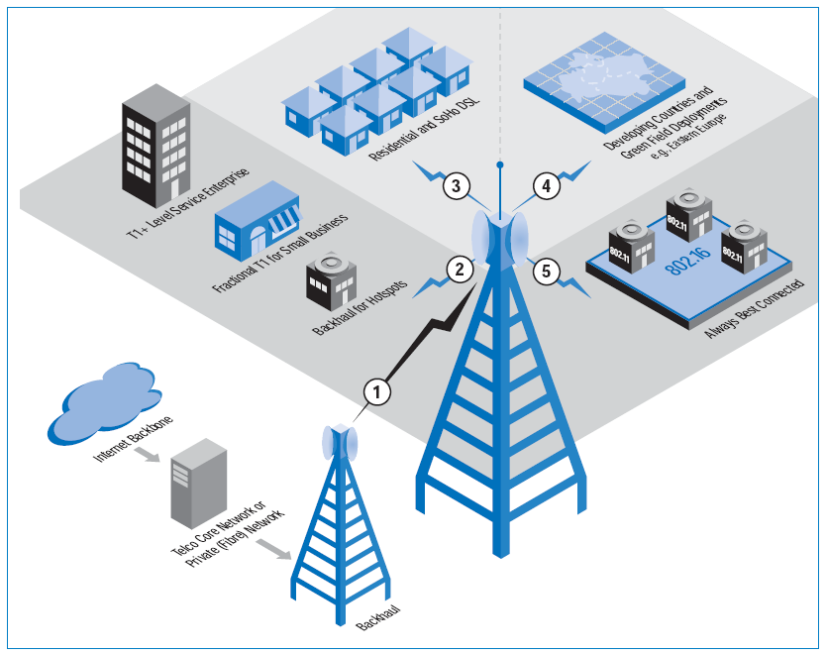
Wireless Internet technology based on IEEE 802.16 is also a natural choice for underserved rural and outlying areas with low population density. In such areas, local utilities and governments work together with a local Wireless Internet Service Provider (WISP) to deliver service. Recent statistics show that there are more than 2,500 WISPs who take advantage of license-exempt spectrum to serve over 6,000 markets in the U.S. On an international basis, most deployments are in licensed spectrum and are deployed by local exchange carriers who require voice services in addition to high-speed data. This is because in these areas the wired infrastructure either does not exist or does not offer the quality to support reliable voice, let alone high-speed data. The term, “Wireless Local Loop” is often used to describe such applications, since it is used as a substitute for traditional copper phone wire in the local loop.
Fig 1 The IEEE 802.16 standard enables solutions that meet the needs of a variety of broadband access segments.

Best-connected wireless services
As the number of IEEE 802.11 hotspots proliferates, users will naturally want to be wirelessly connected, even when they are outside the range of the nearest hotspot. The IEEE 802.16e extension to 802.16a introduces nomadic capabilities which will allow users to connect to a WISP even when they roam outside their home or business, or go to another city that also has a WISP.

WiMAX as Metro access development solution
WiMax is a worldwide certification addressing interoperability across IEEE 802.16 standards-based products. The IEEE 802.16 standard with specific revisions addresses two usage models:
- Fixed
- Portable

Fixed
The IEEE 802.16-2004 standard (which revises and replaces
IEEE 802.16a and 802.16REVd versions) is designed for fixed-access usage models. This standard may be referred to as “fixed wireless” because it uses a mounted antenna at the subscriber’s site. The antenna is mounted to a roof or mast, similar to a satellite television dish. IEEE 802.16-2004 also addresses indoor installations, in which case it may not be as robust as in outdoor installations.
The 802.16-2004 standard is a wireless solution for fixed broadband Internet access that provides an interoperable, carrier-class solution for the last mile. The Intel WiMAX solution for fixed access operates in the licensed 2.5-GHz, 3.5-GHz and license-exempt 5.8-GHz bands. This technology provides a wireless alternative to the cable modem, digital subscriber lines of any type (xDSL), transmit/exchange (Tx/Ex) circuits and optical carrier level (OC-x) circuits.

Portable
The IEEE 802.16e standard is an amendment to the 802.16- 2004 base specification and targets the mobile market by adding portability and the ability for mobile clients with IEEE 802.16e adapters to connect directly to the WiMAX network to the standard. The 802.16e standard is expected to be ratified in early 2005.
The 802.16e standard uses Orthogonal Frequency Division Multiple Access (OFDMA), which is similar to OFDM in that it divides the carriers into multiple subcarriers. OFDMA, however, goes a step further by then grouping multiple subcarriers into sub-channels. A single client or subscriber station might transmit using all of the sub-channels within the carrier space, or multiple clients might transmit with each using a portion of the total number of sub-channels simultaneously. The IEEE 802.16-2004 standard improves last-mile delivery in several key aspects:
- Multi-path interference
- Delay spread
- Robustness
Multi-path interference and delay spread improve performance in situations where there is not a direct line-of-sight path between the base station and the subscriber station.
The emerging 802.16-2004 media-access control (MAC) is optimized for long-distance links because it is designed to tolerate longer delays and delay variations. The 802.16 specification accommodates MAC management messages that allow the base station to query the subscriber station, but there is a certain amount of time delay.
WiMAX equipment operating in license-exempt frequency bands will use time-division duplexing (TDD); equipment operating in licensed frequency bands will use either TDD or frequency-division duplexing (FDD). Intel WiMAX products will support TDD and half-duplex FDD operation.
The IEEE 802.16-2004 standard uses OFDM for optimization of wireless data services. Systems based on the emerging IEEE 802.16-2004 standards are the only standardized OFDM based, wireless metropolitan area networks (WMAN) platforms.
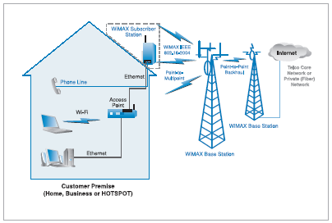
In the case of 802.16-2004, the OFDM signal is divided into 256 carriers instead of 64 as with the 802.11 standard. As previously stated, the larger number of subcarriers over the same band results in narrower subcarriers, which is equivalent to larger symbol periods. The same percentage of guard time or cyclic prefix (CP) provides larger absolute values in time for larger delay spread and multi-path immunity.
Fig 2: WiMAX network topology.

The 802.11 standard provides one-fourth of the OFDM options for CP than does the 802.16-2004 standard, which provides 1/32, 1/16, 1/8 and 1/4, where each can be optimally set. For a 20-MHz bandwidth, the difference between a 1/4
CP in .11 and 16 would be a factor of four because of the ratio 256/64. In OFDMA with 2048 FFT size, the ratio is 32.

The physical layers (PHYs) for both 802.11 and 802.16-2004 are designed to tolerate delay spread. Because the 802.11 standard was designed for 100 meters, it can tolerate only about 900 nanoseconds of delay spread. The 802.16-2004 standard tolerates up to 10 microseconds of delay spread— more than 1000 times than in the 802.11 standard.

Wi-Fi and WiMax as metro-access solution
WISPs (Wireless Internet Service Providers) have been striving for wireless technologies that make wireless metro access possible. Access to areas that are too remote, too difficult or too expensive to reach with traditional wired infrastructures (such as fiber) require new technologies and a different approach.
The three key deployment types that make up wireless metro access are backhaul, last-mile and large-area coverage referred to as hot zones). Wireless last-mile coverage typically uses the Institute of Electrical and Electronics Engineers (IEEE) 802.11 standard with high-gain antennas, while hot zones use modified IEEE 802.11 equipment in a mesh deployment.
Because the IEEE 802.11 standards were designed for unwiring the local area network (LAN), metro-access applications are facing the following challenges:
- Non-standard wireless inter-AP communication. Today, wireless links used to connect 802.11 APs for inter-AP communication in mesh networking are vendor-specific. The proposed IEEE 802.11s standard, estimated to be ratified in 2007, will standardize Wi-Fi mesh networking.
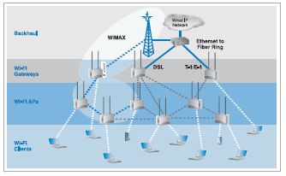
- Providing quality of service (QoS). QoS refers to the ability of the network to provide better service to selected network traffic over various technologies. The goal of QoS technologies is to provide priority (including dedicated bandwidth to control jitter and latency) that is required by some real-time and interactive traffic, while making sure that in so doing the traffic on the other paths does not fail. In general, unlicensed bands can be subject to QoS issues because deployment is open to anyone. Advances in the associated standards and related technologies, however, help mitigate problems with unlicensed bands, such as multi-path interference. The proposed IEEE 802.11e standard, which is projected to be ratified in 2006, will standardize Wi-Fi mesh-network topology.
Fig. 4: Phase 2 – WiMAX as an intra-mesh backhaul option.

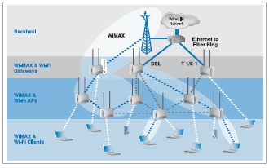
- Expensive backhaul costs. Backhaul refers both to the connection from the AP back to the provider and to the connection from the provider to the core network. To extend wireless access nodes, providers still rely on wires for long-distance coverage. Some providers find wiring large areas too expensive.
Fig 5: Phase 3 – WiMAX as a client connection option.

- Limited services. Without QoS, applications such as voice over Internet protocol (VoIP) may reduce a call’s quality, thus limiting the provider’s ability to tier services and obtain additional revenue streams. Current Wi-Fi last-mile and large-coverage solutions offer excellent data transfers. Some vendors offer proprietary QoS.

- Despite the challenges, wireless metro-access solutions are continuously sought after for the following reasons:
- Wireless metro-access solutions available today, such as mesh networking implementations, are more cost-effective and flexible than their wired counterparts.

- These solutions provide a standards-based connection from AP-to-mobile users for hot-zone coverage.
In this scenario, it is not possible to replace Wi-Fi with WiMax solution; but instead they combined can provide solution for various segments. Adaptation of WiMax can be done in different phases.

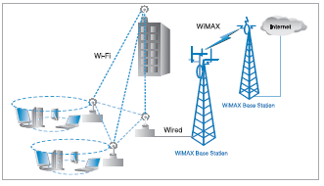
With attention focused on WiMAX, it’s easy to forget that Wi-Fi is also rapidly evolving. Wi-Fi radios are appearing not just in laptops and personal digital assistants (PDAs), but in equipment as diverse as mobile phones, parking meters, security cameras and home entertainment equipment. As a result of the increasing adoption rate, Wi-Fi will continue to become faster, more secure, more reliable and more full featured.
Fig. 3: Phase 1 – WiMAX backhaul for a Wi-Fi mesh topology.

In turn, these advances will drive continued adoption. A combined Wi-Fi mesh and WiMAX deployment, as shown in
Figure 3, offers a more cost-effective solution than a sole Wi-Fi directional-antenna deployment or a Wi-Fi mesh network with wired backhaul for WISPs that want to extend the LAN or cover the last mile.
For intra-mesh connectivity, Wi-Fi offers advantages today.
Industry-proven Wi-Fi chipsets and radios are readily available and economical. They readily operate in unlicensed regions of the spectrum. The result is an intra-mesh technology that offers reliable high performance at the lowest cost. Essentially, the inter-mesh backhaul connections can reduce costs associated with wiring each node. When they become available, the dual Wi-Fi and WiMAX APs will provide higher performance and an even more robust solution.

As shown in Figure 5, APs with dual Wi-Fi and WiMAX radios can be easily integrated into a mesh network. The solid blue links show WiMAX backhaul and inter-mesh connectivity. With the emergence of WiMAX in the near future, deployments that combine the two technologies can be constructed to take advantage of the strengths of both Wi-Fi and WiMAX.
Figure 3 shows the topology that could be used by a municipality that wants to extend broadband connectivity to two new rural community centers and a park. The municipality wants to provide free Internet service to local residences and staff to promote education, cultural arts and local businesses. The deployment must be completed within three months. A combination of WiMAX and Wi-Fi mesh network topology provides the best solution for this situation. WiMAX can be used to aggregate the community centers.

WiMAX extends the reach of broadband, while the proprietary Wi-Fi mesh network available today can provide mobile client access throughout the community centers and park. As dual-mode Wi-Fi and WiMAX cells are introduced into high-capacity network centers in licensed or unlicensed bands. The WiMAX cells will interoperate seamlessly with existing Wi-Fi cells; always selecting the best path for delivering maximum user throughput end-to-end.

Driving factors and challenges in India
According to [11], new technologies such as WiMAX, which have the potential to deliver above 4 Mbps over long distances in a fixed point-to-point or point-to-multipoint configuration, should also be encouraged. In anticipation of standardization of these technologies by the ITU, the spectrum should be de- licensed, in line with international practices, to allow India to take early advantage of such wireless technologies

Following are the Driving factors for WiMax in India: [6] [7]
- 2+ million subscribers added each month
- 3G is costlier and inefficient
- 60% of Urban households can spend under $7 /month on Telecom
- Can spend $ 50 for terminal...
Challenges for WiMax: [7]
- How will it work along with 2.5G / 3G cellular?
- What will be the Infrastructure cost
- India has 700 million rural population in 600,000+ villages in India (about 1000 people per village with per-capita income of $ 0.40 per day)

The WiMax Debate: When is it ready?
As per [9], the advances promised from WiMAX technologies represent a radical shift in the wireless access business model for the scores of manufacturers and carriers involved. But it is also important to note that the shifting is far from over.

WiMAX Forum Certified products are not yet available.
The first product certifications (in the form of 802.16d standards) will not be issued before Q3 2005. In order to ensure that a good number of vendors reach certification right away, the first WiMAX profiles still include a lot of different optional features, such as diversity, space-time coding, and ARQ.

Volume will be driven by portability/mobility applications such as notebooks and PDAs.
These volume benefits, as well as forward-compatibility of the evolving standard, will only be addressed in the 802.16e standard, scheduled for release in Q1 2005. WiMAX-certified 802.16e products are scheduled for release in Q1 2006.

This isn’t Wi-Fi all over again.
Wi-Fi volume ramped quickly because it was a consumer and enterprise access solution—a million little decisions to deploy a wireless LAN. While WiMAX is touted to be able to do everything from wireless LAN to nuclear fission, its sweet spot is for carrier-class access networks. In contrast to Wi-Fi, WiMAX volume will be driven by a relatively small number of strategic decisions to deploy large-scale networks. Such decisions are not made lightly and sales cycles are on the order of 12 to 18 months.

Conclusion
The cost and complexity associated with traditional wired cable and telephone infrastructure have resulted in significant broadband coverage gaps in the India and international geographies. Early attempts to use wireless technology to fill these coverage gaps have involved a number of proprietary solutions for wireless broadband access that have fragmented the market without providing significant economies of scale. High-speed wireless broadband technology based on the IEEE 802.16 standard promises to open new, economically viable market opportunities for operators, wireless Internet service providers, and equipment manufacturers. The flexibility of wireless technology, combined with the high throughput, scalability, long range and Quality of Service features of the IEEE 802.16 standard will help fill the broadband coverage gaps and reach millions of new residential and business customers worldwide.

Acknowledgment
I am thankful to Mr. Preetam Patil for his invaluable guidance and support. And Also, Prof. Kokate for his technical helps and support.

References
- Intel Corp., IEEE 802.16* and WiMAX: Broadband Wireless Access for Everyone, 2003.
http://www.intel.com/ebusiness/pdf/wireless/intel/80216_wimax.pdf
- WiMAX Forum, WiMAX’s Technical Advantage for Coverage in LOS and NLOS Conditions, Aug 2004.
http://www.wimaxforum.org/news/downloads/WiMAXNLOSgeneral-versionaug04.pdf
- WiMAX Forum
www.wimaxforum.org
- WiMAX technology overview
www.intel.com/netcomms/technologies/wimax/
- WiMAX World Conference & Exposition
http://developer.intel.com/technology/itj/2004/volume08issue03/art05_multiantenna/p01_abstract.htm
- WiMAX in India: Opening New Frontiers Through Broadband Connectivity, Nov 2004, Technology@Intel Magazine
- Next Generation Wireless for India, ashok jhunjhunwala, TeNeT Group, IITM, India
- Wireless Technology for bridging Digital Divide in developing countries, 11Sept 2004
Ministry of Posts and telecommunications of Cambodia
- The WiMAX revolution: risk vs. reward, By Stephane Cohen, Director of Marketing, SR Telecom
- Intel corp., Understanding Wi-Fi and WiMAX as Metro-Access Solutions,
http://www.intel.com/ebusiness/pdf/wireless/304471.pdf
- Telecom Regulatory Authority of India, in “Broadband India: Recommendations on Accelerating Growth of Internet and Broadband Penetration,” April 2004.
- AMD Global Consumer Advisory Board, “Charting and Bridging Digital Divides” , Oct. 27, 2003

 Jigar A. Shah is student of Final Year Information Technology, K.K.Wagh College of Engg. Education and Research, Nasik (E-mail: jigar_a_shah83@yahoo.com)

